Data Cleaning

1. Rename the pizza sizes

CTRL + H in the column pizza_size and Replace All.

* S -> Regular
* M -> Medium
* L -> Large
* XL -> X-Large
* XXL -> XX-Large

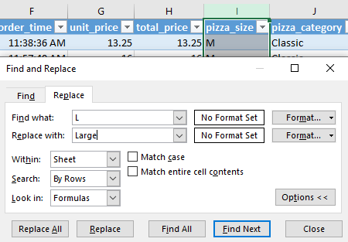

DATA PROCESSING

1. Creating the column order_day

Insert a new column with the formula below:

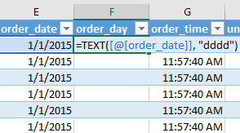

Data Analysis

Creating pivot tables

Insert -> Pivot Table

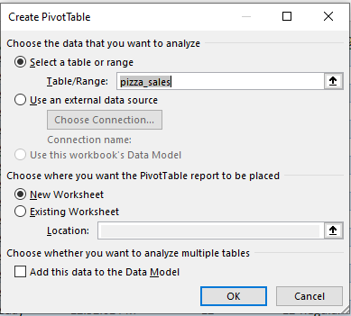

Rename the Pivot Table to KPI , to identify the sheets when applying slicers connections.

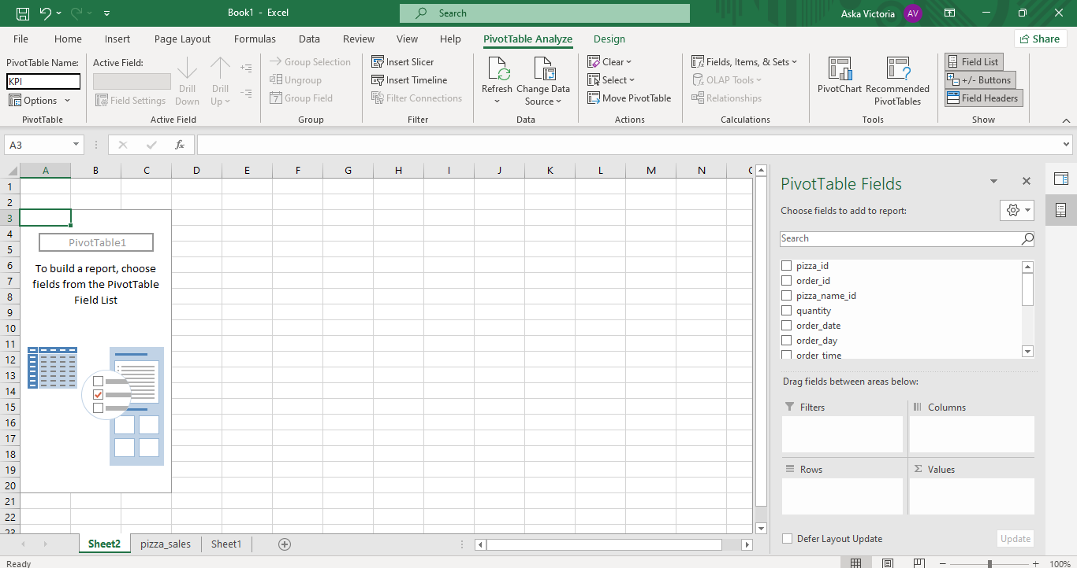

KPI’s Requirements

1. Total Revenue

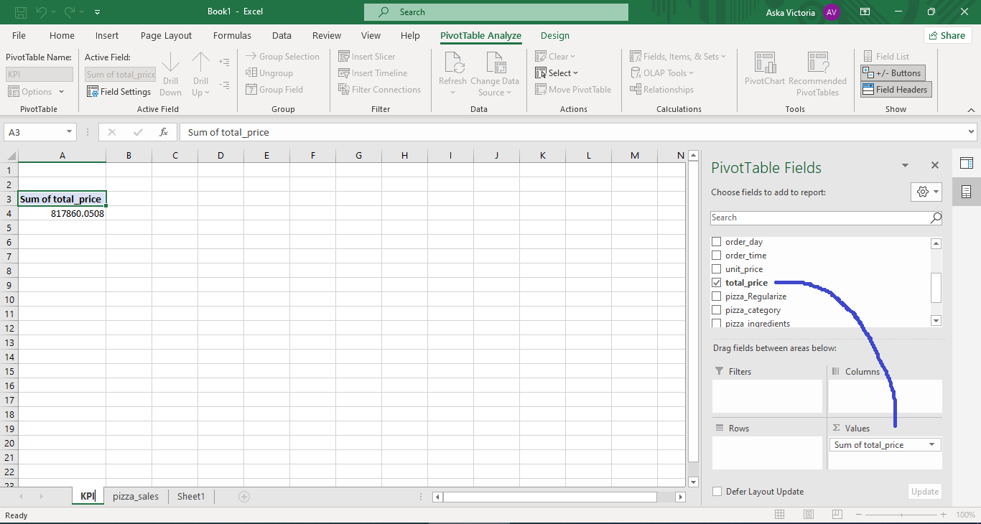

1. Average Order Value

Excel doesn’t have the count distinct function, so we create a column and a function to count the distinct orders.

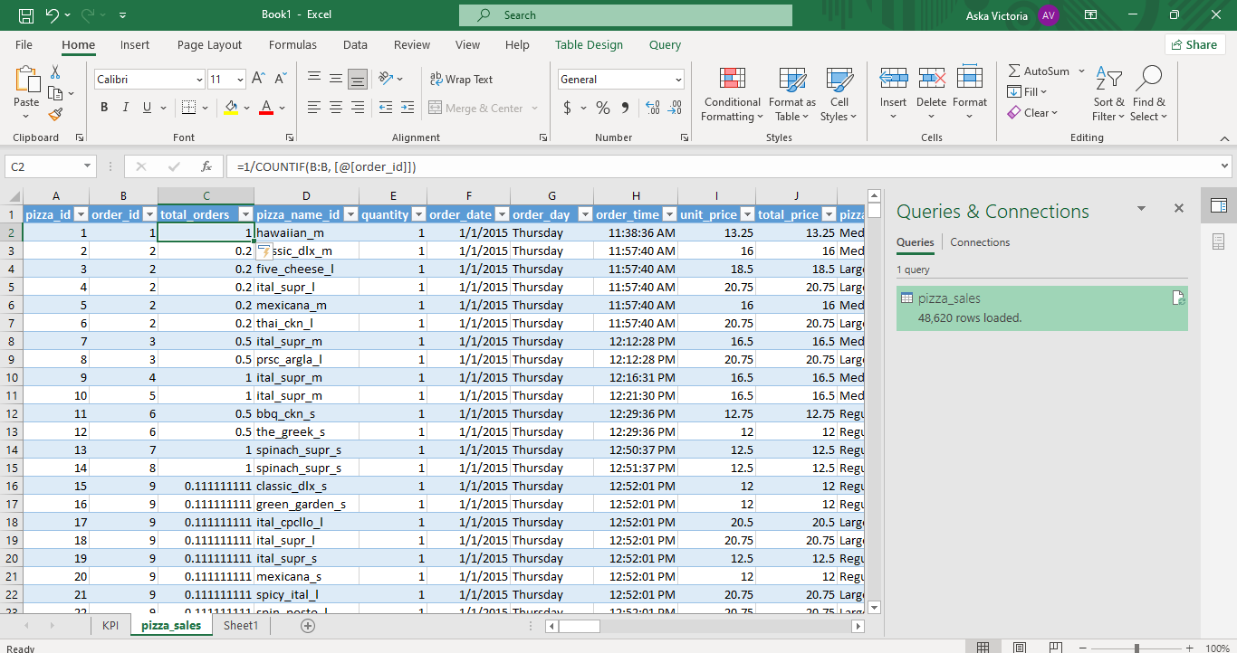

After finding the count of distinct orders, we can calculate the average order value, total_price/total_orders

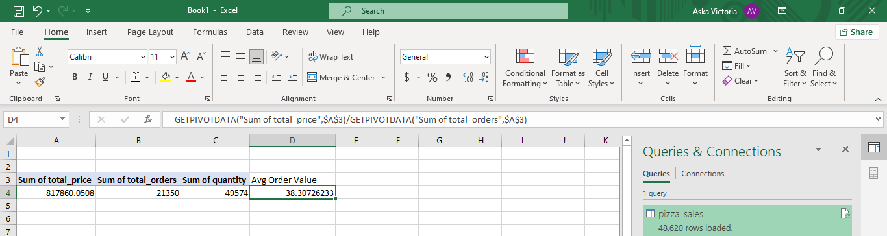

1. Total pizzas sold

Sum of quantity

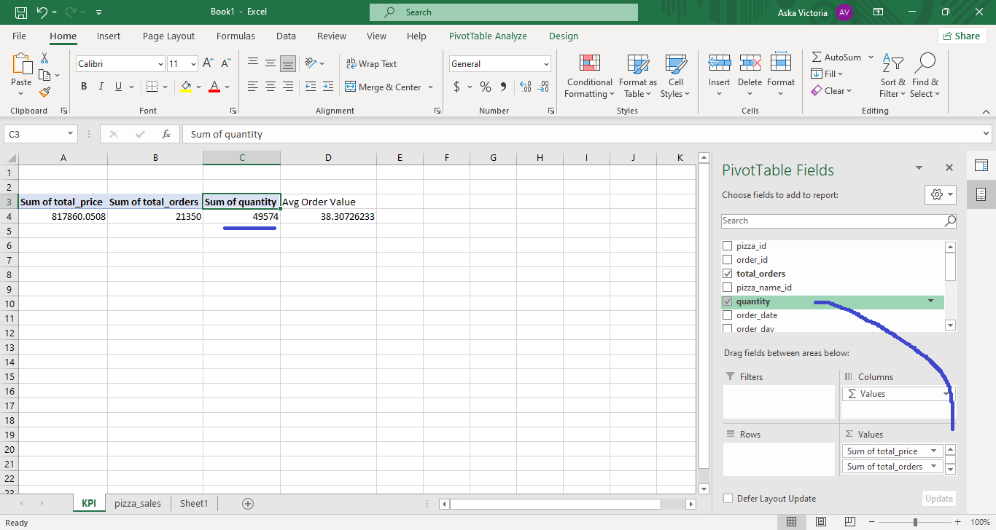

1. Total orders

Excel doesn’t have the count distinct function, so we create a column and a function to count the distinct orders.

